TITLE: Environmental Monitoring

Introduction:

This project involves setting up IOT devices to monitor Environmental condition in public parks, including temperature and humidity .The primary objective is to provide real-time environmental data to park visitors through a public plat from ,enabling them to plan their outdoor activities accordingly .This project includes defining objectives ,designing the IOT sensor system ,developing the environmental monitoring platform ,and integrating them using IOT technology .

Design and Innovation:

Designing an IoT-based environmental monitoring system using Arduino can be a valuable project for tracking and managing various environmental parameters. You can monitor factors like temperature, humidity, air quality, soil moisture, and more. Here's a general outline of the steps involved in such a project:

Components Needed:

Arduino board (e.g., Arduino Uno, Arduino MKR1000, etc.)

Sensors (e.g., DHT22 for temperature and humidity, MQ-series for air quality, soil moisture sensor, etc.)

Wi-Fi module (e.g., ESP8266 or ESP32) or a dedicated IoT development board like Arduino MKR WiFi 1010.

Power source (e.g., batteries or solar panels for remote deployment).

Internet access (Wi-Fi or GSM module for remote monitoring).

Steps to Design an IoT Environmental Monitoring System:

Select Sensors: Choose the appropriate sensors based on the environmental parameters you want to monitor. For example, DHT22 for temperature and humidity, MQ-135 for air quality, soil moisture sensors for agriculture applications, etc.

Arduino Setup:

Connect the sensors to the Arduino board according to their datasheets and guides.

Set up the Arduino development environment on your computer.

Programming:

Write the Arduino code to read data from the sensors.

Use appropriate libraries for sensor interfacing.

Create a data structure to store sensor readings.

Implement error handling and data processing as required.

Wi-Fi Connectivity:

If using an Arduino with built-in Wi-Fi (e.g., Arduino MKR WiFi 1010), configure Wi-Fi settings.

If using a separate Wi-Fi module, write code to connect to your Wi-Fi network.

IoT Platform:

Choose an IoT platform to send and store data (e.g., AWS IoT, Google Cloud IoT, or Blynk for a simpler setup).

Write code to send sensor data to your selected IoT platform using MQTT, HTTP, or other protocols.

Data Visualization:

Create a dashboard or app to visualize the collected data. You can use platforms like ThingsBoard , Ubidots, or build your own using web technologies.

Alerts and Notifications:

Set up alerts and notifications based on specific sensor readings (e.g., sending an email or SMS when air quality deteriorates).

Power Management:

For remote deployments, consider power management solutions like using low-power Arduino boards or incorporating solar panels with battery storage.

Testing and Calibration:

Test the system in the real environment to ensure it's working correctly.

Calibrate sensors if necessary.

Data Analysis:

Gather and analyze the collected data to gain insights into the environmental conditions over time.

Implement data analytics or machine learning if required.

Documentation and Maintenance:

Document your project thoroughly for future reference.

Regularly maintain the system and update it as needed.

Scaling: If necessary, scale your system by adding more sensor nodes and extending the network.

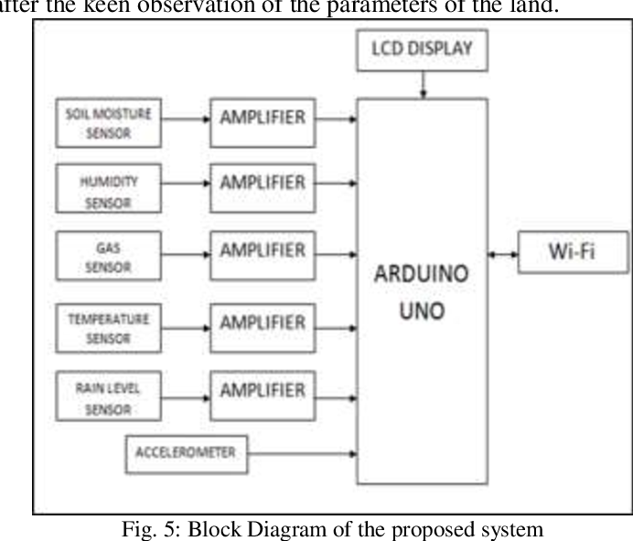

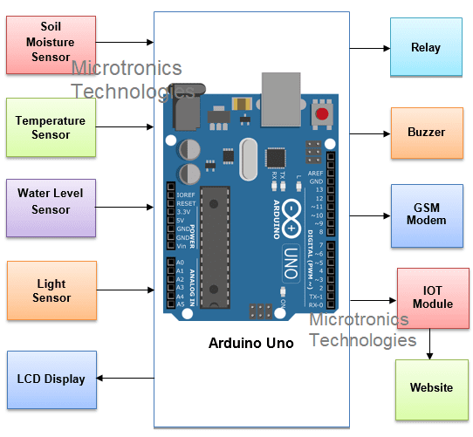

Implementation Strategy:

1. App development :

Hardware Selection:

Choose the appropriate sensors and IoT devices for your project. Depending on your needs, you might use sensors like temperature sensors, humidity sensors, gas sensors, or environmental monitoring stations.

Data Collection and Connectivity:

Set up the sensors to collect data and transmit it over the internet. Common communication protocols include Wi-Fi, Bluetooth, LoRa, or cellular connectivity.

Data Storage:

You'll need a backend system to receive, store, and manage the data from these sensors. Common choices include cloud services like AWS, Azure, Google Cloud, or on-premises servers.

Data Processing and Analysis:

Process and analyze the collected data. This can involve techniques like data filtering, aggregation, and real-time analysis to detect anomalies or trends in the environmental data.

User Interface Development:

Create a user-friendly interface for accessing the monitored data. This can be a web application, a mobile app, or both. Ensure the interface provides visualizations, charts, and alerts for users.

Alerting and Notifications:

Implement an alerting system that notifies users when certain environmental parameters exceed defined thresholds. Alerts can be sent via email, push notifications, or SMS.

Data Visualization:

Use charts, graphs, and maps to visually represent the environmental data. Tools like D3.js, Chart.js, or Mapbox can be helpful for this.

User Authentication and Authorization:

Implement a secure user authentication system to control who can access the data. This is especially important for protecting sensitive environmental data.

Scalability and Reliability:

Ensure your system can handle a growing number of sensors and users. Use best practices for scalability and redundancy to maintain high availability.

Testing and Quality Assurance:

Thoroughly test your app to ensure it's working as intended. Test data accuracy, system performance, and security.

Deployment:

Deploy your app and IoT infrastructure in the target environment, whether it's a city, industrial facility, or research station.

Maintenance and Updates:

Regularly maintain and update your app to ensure it stays secure and up-to-date with the latest technologies.

Compliance and Regulations:

Ensure that your app complies with any relevant environmental regulations and data privacy laws.

Education and Training:

Provide necessary training to users and stakeholders who will be using the environmental monitoring app.

B. IOT integration and Testing

Testing and Validation:

Perform unit testing on each IoT device to ensure they are working correctly. Test sensor accuracy and reliability.

Conduct integration testing to verify that all devices work together seamlessly.

Test data transmission and reception.

Validate data accuracy and consistency.

Security Testing:

Ensure that your IoT network is secure. Implement security best practices such as device authentication, data encryption, and regular updates.

Scalability Testing:

Test how the system performs as you add more devices or sensors. Ensure it can handle the expected growth in data and devices.

Interoperability Testing:

Verify that your IoT devices and sensors can interoperate with other third-party systems or platforms if necessary.

Environmental Conditions Testing:

Test your system under various environmental conditions to ensure it can withstand extremes such as temperature, humidity, or exposure to the elements.

Data Analytics and Insights:

Implement data analytics to derive meaningful insights from the collected data. This can involve machine learning and AI techniques.

Monitoring and Maintenance:

Set up continuous monitoring for your IoT devices to detect and address issues in real-time.

Establish a maintenance plan for firmware updates, battery replacement, and sensor calibration.

Regulatory Compliance:

Ensure your environmental monitoring solution complies with any local or industry-specific regulations.

Documentation:

Maintain detailed documentation for the entire system, including device manuals, data structures, and testing reports.

Deployment:

Deploy the system in the target environmental monitoring locations.

User Training:

Train users or operators on how to use the system and interpret the data.

Benefits:

Improved Accuracy: IoT sensors provide high-precision measurements, reducing the margin of error compared to traditional monitoring methods. This accuracy is crucial for assessing the impact of environmental changes and identifying trends.

Reduced Environmental Impact: By providing actionable data for optimizing processes and resource usage, IoT-based monitoring can help organizations reduce their own environmental impact, contributing to sustainability efforts.

Public Health and Safety: Environmental monitoring can directly impact public health by identifying air and water quality issues and enabling timely responses to protect the well-being of communities.

Conclusion:

In conclusion, implementing IoT devices to monitor environmental conditions in public parks is a promising and innovative approach with several significant benefits. These devices offer real-time data collection and analysis, which can help park authorities, environmentalists, and the general public make informed decisions regarding park management, conservation efforts, and overall park experience.

TEAM MEMBERS: K.Thenmozhi-921021106029

A.Jaseema-921021106011

K.Sishani-921021106027

A. Sakana Sri-921021106022